# CPT_Logo_Manual.jpg Meeting Workspaces and Document Workspaces

**Lab Time**: 60 minutes

**Lab Overview:** In this lab you will link a new event to an existing meeting workspace. You will also utilize an existing document workspace.

## Exercise 1: Link a New Calendar List Event to a Meeting Workspace

In this exercise you will link a new Calendar list event to an existing Meeting Workspace and use the workspace to organize meeting details.

1. Log into your site collection using the account **Ken Sanchez**.
2. Using Internet Explorer, browse to the URL of the SharePoint site collection you were provided to use when working on the hands on labs in this course.
3. When prompted to login, enter [[AD-DOMAIN]]\ken in the **User Name** field and click **OK**. Use the password specified in the *Hands-On Lab Overview* document provided in the student manual.

**Note**: If you are not prompted to login & if you are logged in as another user use the Welcome Menu to logout and login as a different user.

1. Navigate to the **Sales Meeting** meeting workspace sub-site:
2. Click the link to the **Sales Meeting** workspace in the Top Navigation Bar.

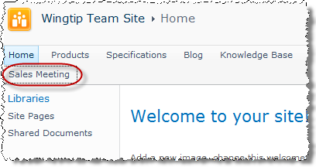

1. Notice that the meeting workspace is not yet associated with any particular event.
2. Return to the **Wingtip Team Site** site using the **Navigate Up** button at the top of the page.
3. Navigate to the **Calendar** list by clicking on the list's link in the Quick Launch Bar.
4. Create a new event in the calendar:
5. Click the **New Event** link in the **Events** tab in the **Calendar Tools** contextual tab group in the ribbon.

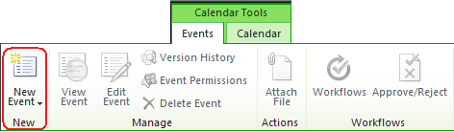

1. In the resulting **Calendar - New** item dialog box, enter the following information the click **Save**:

**Title:** Sales Meeting

**Location:** Conference Room

**Start Time:** Date = select one week from today; Time =1:00pm

**End Time:** Date = select one week from today; Time = 2:00pm

**Description:** A meeting to determine sales territories.

**Category:** Meeting

**All Day Event:** Leave unchecked

**Recurrence:** Leave unchecked

**Workspace:** Check the box

1. On the **New or Existing Meeting Workspace** Web page, link the new event to an existing meeting workspace by selecting the radio button entitled **Link to an existing Meeting Workspace** and choosing **Sales Meeting** from the drop-down menu. Notice that all remaining options gray out because they are the configuration settings for creating a new meeting workspace Web site and are no longer appropriate. Click **OK**.

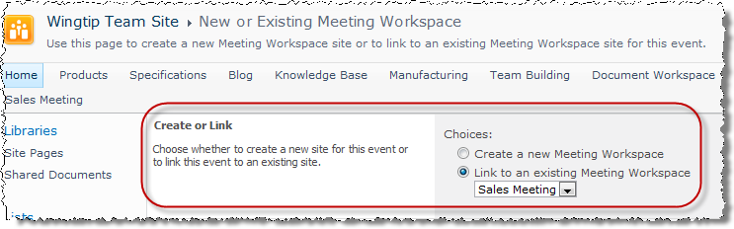

1. Once delivered to the **Sales Meeting** meeting workspace sub-site, notice that the site is now associated with the Calendar event that you linked to it:

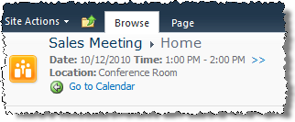

1. Add an objective to the **Objectives** list on the **Sales Meeting** workspace by clicking the **Add new item** hyperlink at the bottom of the list's Web Part on the default page of the site.

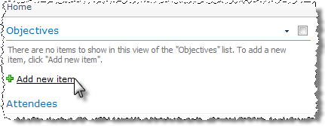

1. Enter the following objective: **Determine the practicality of redefining the American sales territories according to customer base rather than geographic disbursement**. Click **Save** to enter new item.
2. Add an agenda item to the **Agenda** list on the **Sales Meeting** workspace by clicking the **Add new item** hyperlink at the bottom of the list's Web Part on the default page of the site. Use the following information for the new item:

**Subject:** Meeting Opening

**Owner:** Janice Galvin

**Time:** 1:00pm

**Notes:** Welcome, roll call, announcements

1. Add a second item to the **Agenda** list on the **Sales Meeting** workspace by clicking the **Add new item** hyperlink at the bottom of the list's Web Part on the default page of the site. Use the following information for the new item:

**Subject:** Current Territories

**Owner:** Michael Sullivan

**Time:** 1:15pm

**Notes:** Michael will describe current sales territories and the strategy behind them.

1. Add one tentative attendee directly to the **Attendees** list on the **Sales Meeting** workspace by clicking the **Manage Attendees** hyperlink at the bottom of the list's Web Part, then use the **New Item** button in the **List Tools »** **Items** tab in the ribbon to enter the attendee and click **Save**:

**Name:** Michael Sullivan

**Comment:** <none>

**Response:** Tentative

**Attendance:** Optional

1. Create a new document on your workstation using Microsoft Word named Sales Territory Breakdown.docx, add some content to it and save it to the desktop:
2. Upload Sales Territory Breakdown.docx to the **Document Library** on the **Sales Meeting** workspace by clicking the **Add document** hyperlink at the bottom of the library's Web Part, browsing to the directory and selecting the file then clicking **Open**.
3. View the **Sales Meeting** meeting workspace sub-site as Michael Sullivan, a non-organizer but an attendee of the meeting:
4. From the **Welcome Menu** in the top-right corner of the page, select on **Sign in as Different User**.
5. Enter [[AD-DOMAIN]]\michael for a User Name & click **OK**. Use the password specified in the *Hands-On Lab Overview* document provided in the student manual.
6. Notice Michael has limited access to the meeting information. He can add documents, agenda items and objectives, but he cannot manage attendees.
7. View the **Sales Meeting** meeting workspace sub-site as Janice Galvin, a non-organizer and not an attendee of the meeting:
8. From the **Welcome Menu** in the top-right corner of the page, select on **Sign in as Different User**.
9. Enter [[AD-DOMAIN]]\janice for a User Name & click **OK**. Use the password specified in the *Hands-On Lab Overview* document provided in the student manual.
10. Notice Janice has limited access to the meeting information and cannot add any content.

In this exercise you linked a new calendar list event to an existing meeting workspace and explored the benefits of managing meeting details in the workspace.

## Exercise 2: Link a New Outlook 2010 Meeting to an Existing Meeting Workspace

In this exercise you will link a new meeting in Outlook to an existing Meeting Workspace and use the workspace to organize meeting details.

***Note: Students can only perform this exercise if they have Microsoft Outlook 2010 installed on their workstation. If Outlook 2010 is not installed, you can walk through this exercise but you won’t be able to perform any steps.***

1. Log into your site collection using the account **Janice Galvin**.
2. Using Internet Explorer, browse to the URL of the SharePoint site collection you were provided to use when working on the hands on labs in this course.
3. When prompted to login, enter [[AD-DOMAIN]]\janice in the **User Name** field and click **OK**. Use the password specified in the *Hands-On Lab Overview* document provided in the student manual.

**Note**: if you are not prompted to login & if you are logged in as another user use the Welcome Menu to logout and login as a different user.

1. Navigate to the **Products** subsite.
2. Click the link to the **Calendar** list in the Quick Launch Bar.
3. Connect the **Calendar** list on the **Products** site to your Outlook profile:
4. Click the **Connect to Outlook** button in the **Connect & Export** group of the **Calendar** tab within the **Calendar Tools** contextual tab group in the ribbon:

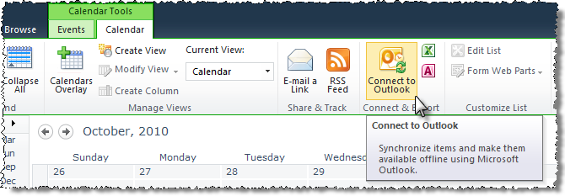

1. Click **Allow** in the pop-up prompt regarding the Web site opening a program.

**Note**: This will not happen if you already have Outlook 2001 open.

1. Click **Allow** in the Internet Explorer Security prompt regarding the Web site opening web content via Outlook.
2. Click on the **Advanced** button in the Microsoft Outlook pop-up prompt asking to **Connect this SharePoint Calendar to Outlook** and note the editable options. *DO NOT change any settings.* Click **Cancel** in the **SharePoint List Options** dialog box to return to the Microsoft Outlook pop-up prompt.
3. Click on the **Yes** button in the Microsoft Outlook pop-up prompt asking to **Connect this SharePoint Calendar to Outlook** to complete the connection.
4. If prompted, login as Janice Galvin.
5. The **Products** site's **Calendar** list should now appear in a new color next to Student's personal calendar in Microsoft Outlook 2010.

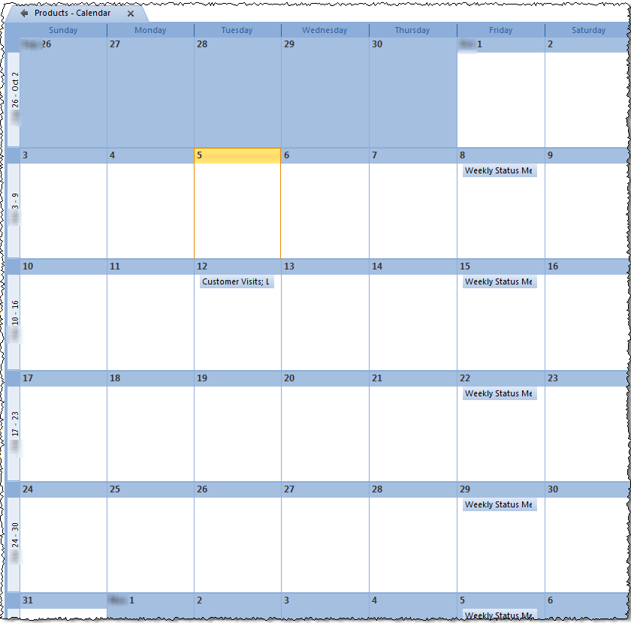

1. Start a new meeting for the Products calendar from within Microsoft Outlook 2010:
2. Click the **Products - Calendar** tab to be sure the following activity occurs on the **Products** SharePoint site's **Calendar** list and your personal calendar in Outlook.
3. From the **New** group of the **Home** tab in the ribbon in **Outlook**, click the **New Meeting** button to create a new meeting request in the Products site's Calendar list:

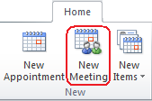

1. A new **Untitled - Meeting** dialog will appear allowing you to enter meeting information (which will be specified after the next step).
2. Add the Meeting Workspace icon to the **Untitled - Meeting** window's Quick Access Toolbar.
3. Click on the drop-down arrow to the right of the Outlook Quick Access Toolbar at the top of the Outlook Window and select **More Commands**:

M4_Lab06a.png

1. In the resulting dialog box, single click **Meeting Workspace** from the list of **Popular Commands** on the left to highlight it, click the **Add** button to add the icon to the Customize Quick Access Toolbar list on the right, then click **OK** to complete the customization.

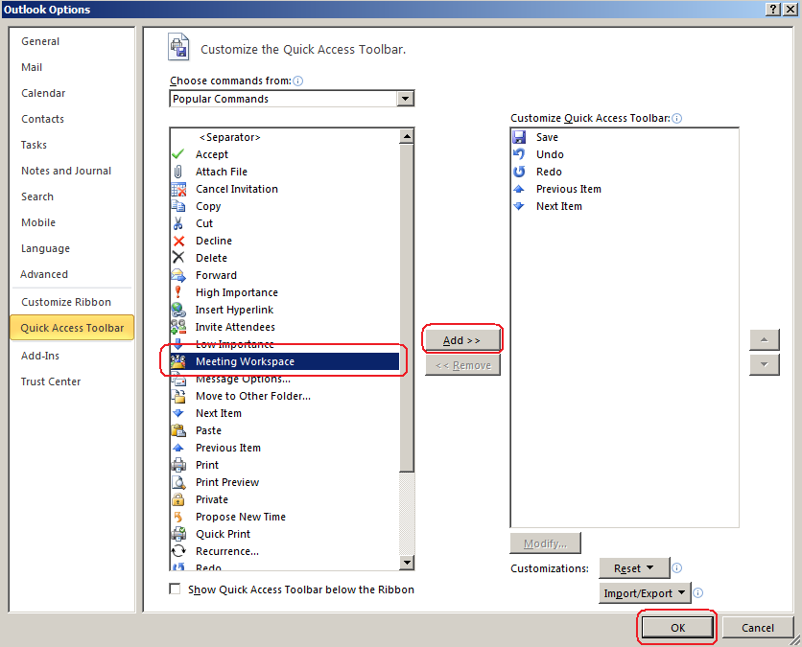

1. Verify that you now see a Meeting Workspace icon in the Quick Access Toolbar at the top of the Untitled - Meeting window.

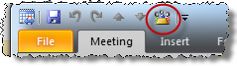

1. Enter the following details into the meeting request but DO NOT save or close it yet:

**To:** mike@wingtip.com = Required; janice@wingtip.com = Optional

**Subject:** Vendor Acceptance

**Location:** 5th Floor Meeting Room

**Start Time:** Next Friday from today - 2:30pm

**End Time:** Next Friday from today - 5:00pm

**Notes:** Vendor selections for next year will be decided in this meeting.

1. Click the **Meeting Workspace** icon in the **Untitled - Meeting** window's **Quick Access Toolbar** to produce the **Meeting Workspace** panel on the right side of the window.

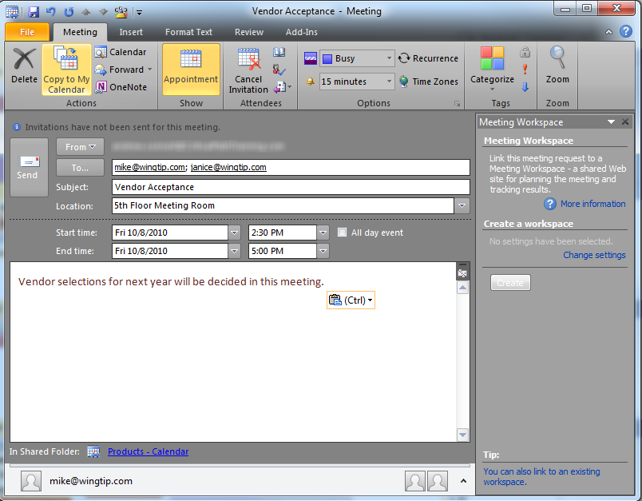

1. Use the **Meeting Workspace** panel to link the new meeting with an existing meeting workspace titled Vendor Meeting:
2. Click on the **You can also link to an existing workspace** hyperlink at the bottom of the Meeting Workspace panel:
3. In the next **Meeting Workspace** panel, click on the drop-down menu of **Step 1: Select a location** and choose **Other...**
4. In the **Other Workspace Server** pop-up, enter the URL to the **Wingtip Team Products** site:

[[URL of your student HOL site collection]]/Products

1. The **Meeting Workspace** panel would now allow you to either create or link to an existing meeting workspace if you had the appropriate permissions. Due to how the lab environment is configured it isn’t possible to load all users with the appropriate permissions ahead of time. You can image how this would work in that the meeting would be added to the calendar and a new workspace would be created, similar to the previous exercise.
2. Click the **Cancel** button in the **Meeting Workspace** panel to cancel the link to an existing workspace.
3. Click the **Delete** button in the **Meeting** ribbon to delete the new meeting from the calendar. Answer the prompt **Yes** to fully delete the new meeting item.
4. Delete the linked **Products** calendar from Outlook by right-clicking the **Products – Calendar** item in the **Other Calendars** section of the Calendar pane at the left of Outlook and choosing **Delete Calendar**. Answer the prompt **Yes**.

In this exercise you linked a new meeting in Outlook to an existing Meeting Workspace in SharePoint and utilized the workspace to organize meeting details.

## Exercise 3: Work on a Document in a Document Workspace

In this exercise you will create a new document and link it to a Document Workspace. You will then edit the document in the workspace and publish your edits to the original source location.

1. Log into your site collection using the account **Ken Sanchez**.
2. Using Internet Explorer, browse to the URL of the SharePoint site collection you were provided to use when working on the hands on labs in this course.
3. When prompted to login, enter [[AD-DOMAIN]]\ken in the **User Name** field and click **OK**. Use the password specified in the *Hands-On Lab Overview* document provided in the student manual.
4. Click the link to the **Specifications** sub-site in the Top Navigation Bar.
5. Send the **Mech Specs** document from the **Shared Documents** document library on the **Specifications** site to a new document workspace:
6. Click the **Shared Documents** Web Part **Title** that appears in the **Shared Documents** document library's Web Part on the home page of the **Specifications** site to visit the actual library.

**Note**: this library has Force Check Out enabled and Versioning set to Major and Minor.

1. Open the **Mech Spec** item in Read-Only view in Microsoft Word and make note of its contents. Exit Microsoft Word (*click* ***Don't Save*** *if prompted*).
2. Check the checkbox box for the **Mech Specs**:

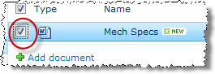

1. Click on the **Send-To** button from the **Copies** group of the **Documents** tab in the ribbon and choose **Create Document Workspace**:

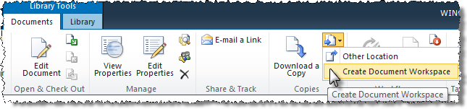

1. Click **OK** on the page that asks if you want to create the new **MechSpec Document Workspace** to complete creation of a new document workspace for the MechSpec.docx document. You will arrive into the new workspace automatically.
2. Examine the **MechSpec Document Workspace** document workspace:
3. Note the lists that can be populated with items specific to the work occurring on this **MechSpec** document (links to helpful websites, tasks for specific authors, calendar events indicating milestones in the project, etc.). Some of these lists already contain items (specifically **Announcements** and **Shared Documents**).
4. Notice the **Members** Web Part on the home page, which displays hyperlinks to the SharePoint security principals who have authority to be in the document workspace.

**Note**: the Add new user hyperlink appears for everyone whether you have the authority to assign permissions on the workspace or not. But don't worry, SharePoint will display an error if an unauthorized user clicks the link and attempts to add additional users to the workspace's security structure.

1. Click the **All Site Content** link in the Quick Launch Bar of the document workspace and make note of the various lists and libraries available on the site. The document workspace contains lists and libraries very similar to the makeup of a default Team site.
2. Click the **Shared Documents** library's link and open the **MechSpec** item in Read-Only view in Microsoft Word and notice its contents are identical to the original **MechSpec** document in the library on **Specifications**. Leave the document open in Microsoft Word for the next step.
3. Edit the **MechSpec** document in the document workspace:
4. Use the **Edit Document** button area just below the ribbon in Microsoft Word to get the document out of Read-Only view.
5. Add a new line to the document indicating you are making this edit on the document located in the **MechSpec** **Document Workspace** as a user named Ken Sanchez at the current date and time.
6. Save your changes to the document and Exit Microsoft Word.
7. You should still have an Internet Explorer window open to the **Shared Documents** library of the **MechSpec Document Workspace** from the previous step.
8. Verify your edit to the **MechSpec** document by opening it again in Read-Only view in Microsoft Word.
9. Exit Microsoft Word.
10. You should still have an Internet Explorer window open to the **Shared Documents** library on the **MechSpec Document Workspace**.
11. Add a Task to the Tasks list in the MechSpec document workspace:
12. Click the **Add new item** in the Tasks list's Web Part and enter the following:

**Title:** Finalize Table of Contents pages

**Predecessors:** <none>

**Priority:** Normal

**Status:** Not Started

**% Complete:** 0

**Assigned To:** Michael Sullivan

**Description:** Please finalize the TOC pages in the MechSpec document.

**Start Date:** {Today's date}

**Due Date:** {One week from today}

In this exercise you practiced using a document workspace to work on a document.